ACHD Final Project Report - Part 1
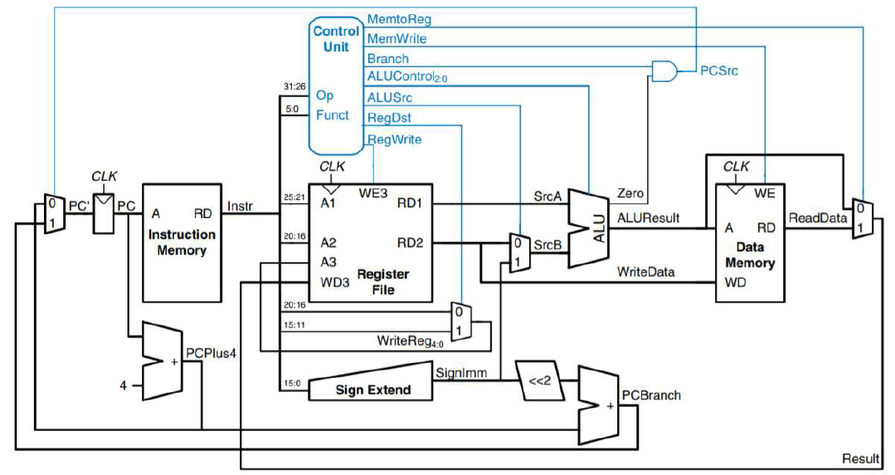
Individual components:
- Instruction Memory:
As described in the project requirement, the IM module is used to restore all the instruction needed to be executed in correct order. In this simulation, the instruction is set to the part 1 sample code.
00000100000000010000000000000111 --ADDI R1, R0, 7 // R1 = 7
00000100000000100000000000001000 --ADDI R2, R0, 8 // R2 = 8
00000000010000010001100000010000 --ADD R3, R1, R2 // R3 = R1 + R2 =15
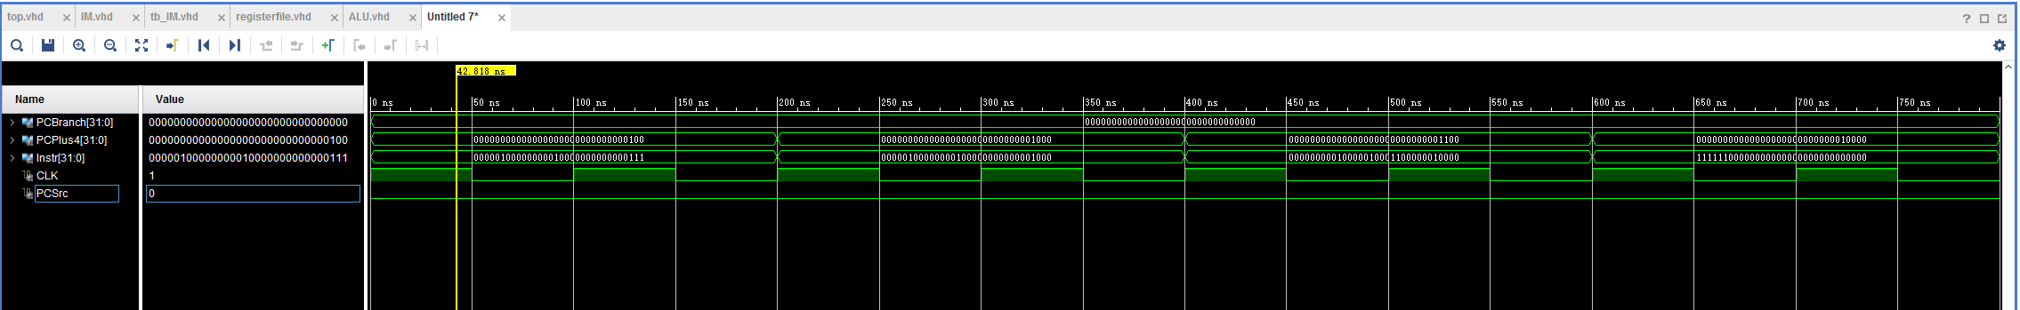11111100000000000000000000000000 --HAL // HALT
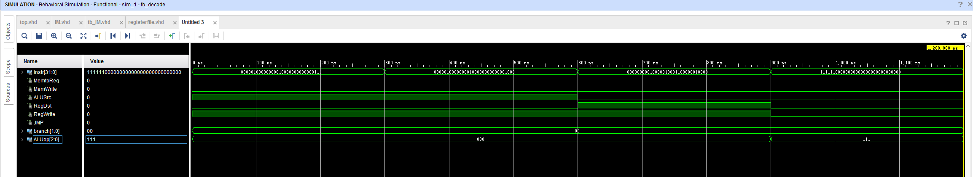
- Decoder:
Decoder unit for the circuit (which is the control unit in the image)
The input of instruction is just the test code 1 from part 1 requirement
- Register file:
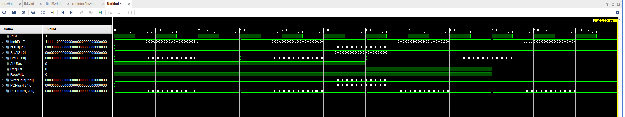input instruction also comes from the example part 1 code which have 4 instructions, the input of ALUSrc, RegDst, RegWrite comes from the same time output of the decoder simulation up above.

- ALU:
Block Diagram:
ALU is one of the necessary component in a processor. It is responsible for arithmetic, logic and immediate operations like Addition, Subtraction, AND, OR, NOR, Left Shift and Right Shift. The unit receives two inputs srcA and srcB each of 32 bit.
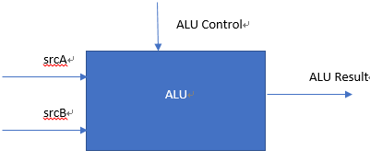
One input is from the register file and the other input is from the register file or instruction memory directly. ALUControl is a control signal based on which the corresponding operation to be performed by ALU is selected. The output is sent as an address to Data Memory Unit.
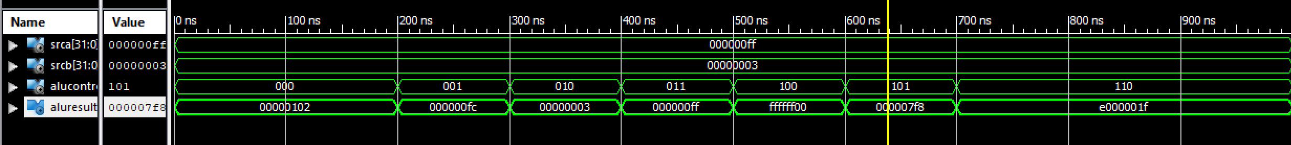
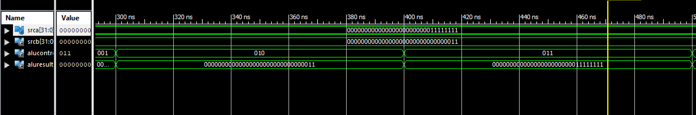
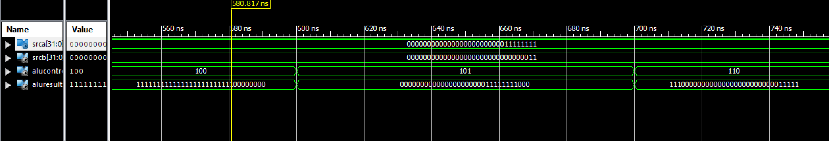
Operation Table:
Operand 1 (srcA) | Operand 2 (srcB) | ALU Operation  (ALUControl) | ALUResult
000000FF | 00000003 | 000 (Add) | 00000102
000000FF | 00000003 | 001 (Subtract) | 000000FC
000000FF | 00000003 | 010 (AND) | 00000003
000000FF | 00000003 | 011 (OR) | 000000FF
000000FF | 00000003 | 100 (NOR) | FFFFFF00
000000FF | 00000003 | 101 (Left Shift) | 000007F8
000000FF | 00000003 | 110 (Right Shift) | E000001F

Resource Utilization:
 | Synthesis Stage | Place and Route Stage
LUT FF Pairs Used | 322 | 306
Fully Used LUT FF Pairs | 0 | 0
Number of bonded IOBs | 99 out of 210 | 99 out of 210

- Data Memory:
The Data Memory, RAM, is an array of 64 memory locations. Each having a 32-bit data. Some of the test case simulations are done using a testbench and some are done by simply forcing the values.
- To write data and read output.
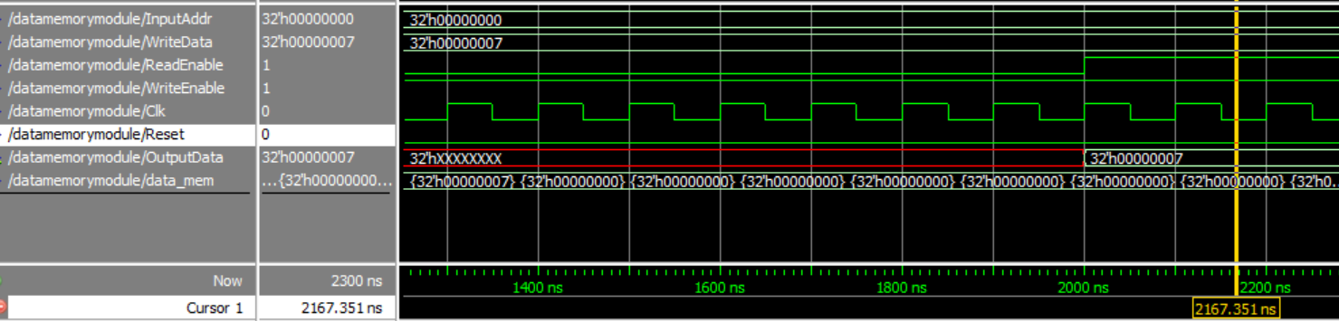
Here I want to write data to Data Memory location 32h’0, i.e. the first location. The data to be written is 32h’07.
So, first I made the read enable ‘0’ (disabled reading) and wrote the data in the memory location that we want. Then once I ran a couple of those cycles, I made read enable ‘1’ to read the output data. The output data is the data shown of the memory location where changes are made.
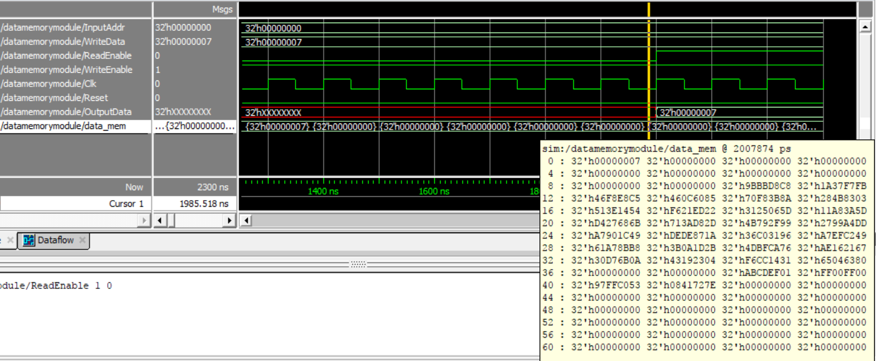
In the image above, you can see that the 0th memory location has the new data, 32h’00000007 written in it (encircled in red).
- To read data
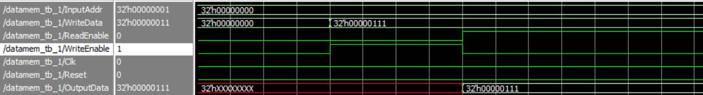
Summary of Resource Utilization in Data Memory Simulation:

 | Synthesis Stage | Place and Route Stage
Slice LUTs | 780 | 746
LUT FF pairs used | 2794 | 2215
LUT FF pairs with unused FFs | 714 | 135
LUT FF pairs with unused LUTs | 2014 | 1469
Fully used LUT-FF pairs | 66 | 611
Number of bonded IOBs | 74 | 74
Reason for the Difference | This is an estimate of the design requirements and not the actual number, so the LUTs used are more. The information here is quite limited and inaccurate. | Here, actual hardware realization is performed. This is done by modelling the circuit and then the requirements report is generated. Thus, the LUT values go down. The information given here is detailed and accurate.

GitHub link: https://github.com/Nie13/6463processor

